**Reusable Component: Downloading multiple files at a time**

**Implementation:**

* Getting object of all the individual file through a SUB Microflow (Refer picture) which will return the respective object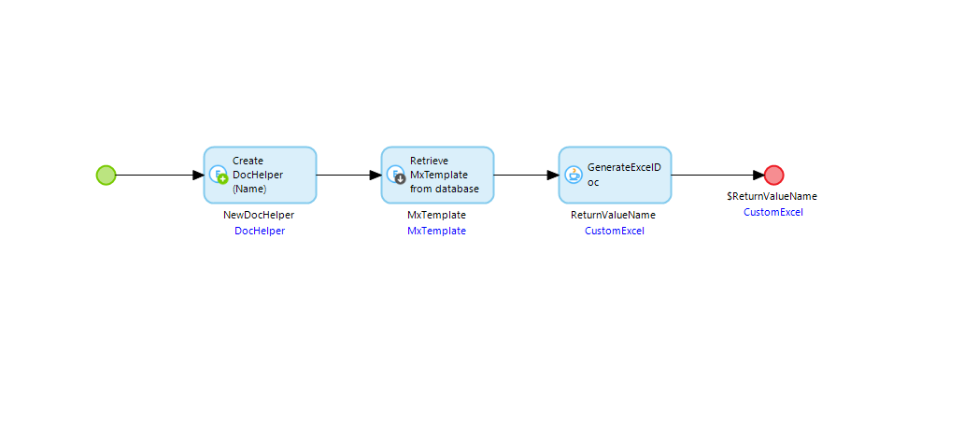
* Passing the SUB microflows in the parent Microflow, where all the objects will be aggregated in the list of System.FileDocument. 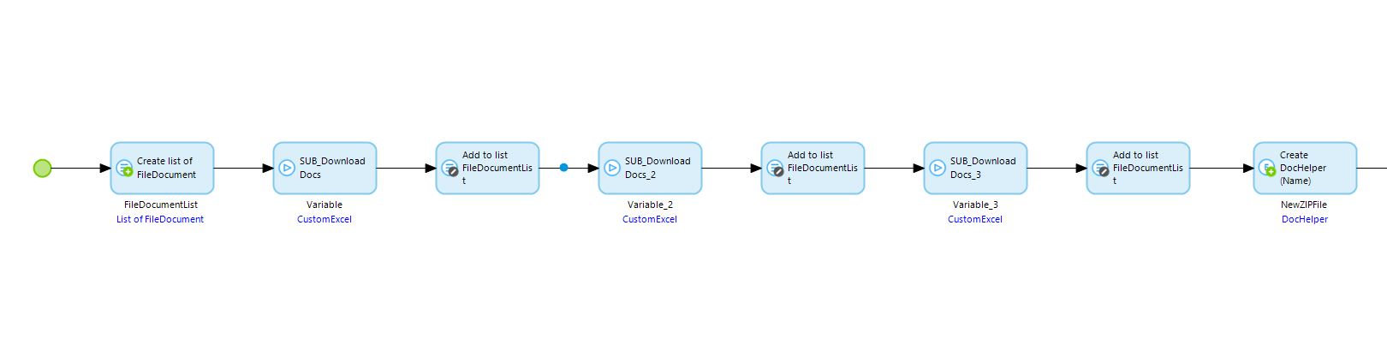
* To get the Zip file of the list of documents we have to pass the list to Java action ‘Zip Document’ and a object of System.FileDocument where we can define the name of the downloaded Zip file. 